May 20, 2024
Seafood production soars in Xinjiang, home to China’s Uyghur population
Seafood Source
Mark Godfrey
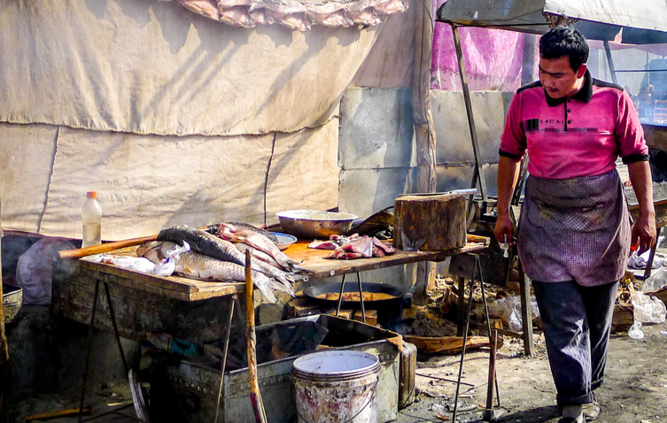
Xinjiang, a region that is home to China’s Uyghur Muslim minority population at the center of allegations of forced labor in the Chinese seafood industry, has markedly increased its seafood production.
The Xinjiang Production and Construction Corps, also known as Bingtuan, is a corporate unit of the Chinese army that controls vast swathes of Xinjiang and trades as the China Xinjian Group. It was founded in the 1950s to cultivate agricultural tracts of the then sparsely populated Xinjiang region at a time of Sino-Soviet tensions and fears by Beijing of a Russian invasion.
The production value of Bingtuan’s fishery output totaled CNY 112 million (USD 15.6 million, EUR 14.5 million) in Q1 2024, up 12.4 percent year over year, lifted by rising output of crab, crayfish, and sturgeon, among other species. The data was released by the Bingtuan Agriculture and Rural Affairs Bureau.
Products made in Xinjiang or suspected of having been made with forced Uyghur labor anywhere in China are banned from entering the United States under the Uyghur Forced Labor Prevention Act (UFLPA). The U.S. Department of Homeland Security maintains a list of Chinese companies that conduct business in Xinjiang or that have been shown to employ Uyghur labor.
The Outlaw Ocean Project released a report in October 2023 revealing how seafood processed with Uyghur labor is making it into the U.S. seafood supply chain. The report led several U.S. seafood purchasers to cut ties with processors in Shandong province and to the filing of a Magnitsky Sanctions recommendation.
For its part, the Chinese government has complicated the work of auditing firms hired to investigate labor issues in Xinjiang supply chains. Seafood sustainability eco-label programs have also come under fire for their own failures to identify the use of Uyghur and North Korean labor in Chinese seafood-processing plants they certified, and the Aquaculture Stewardship Council announced its withdrawal from the Chinese market in March.
On 30 April, U.S. Labor Department Deputy Undersecretary for International Affairs Thea Lee testified at a meeting of the Congressional-Executive Commission on China that Beijing had made it "essentially illegal" to conduct independent human rights audits in Xinjiang.
"If it is impossible to do that, the only responsible thing to do is not to operate in that atmosphere,” Lee said.

January 18, 2024
Seafood to feature in Pinduoduo's CNY 3 billion Chinese New Year sales push
Mark Godfrey
Seafood Source

Imported seafood could be in for a bumper Chinese New Year thanks to a huge marketing campaign from online retailer Pinduoduo.
The Shanghai-based company told media at a launch ceremony it is spending CNY 3 billion (USD 420 million, EUR 390 million) on advertising and discounts, including on seafood products that are typically favored gifts during the Chinese New Year festival, which falls on 10 February this year.
Argentine red shrimp, Norwegian “Arctic” cod, and Irish brown crab are among the seafood items the company is promoting. Irish crab was allowed to reenter the Chinese market in 2023 after a long period of heavy scrutiny due to issues over claims from Chinese authorities of excess cadmium levels in the product.
One of its best-selling items, however, has been a domestic product: freshwater crabs from Xinjiang – a region in far western China. Exemplifying the brand's far reach across the country, Pinduoduo also signed a deal with the municipal government of Qingdao in 2020 to operate an e-commerce streaming studio, subsidized by Qingdao’s government, to promote local seafood brands and products.
Pinduoduo competes against other platforms by offering “red envelopes,” or vouchers, which customers use as discounts on their purchases. In China, Pinduoduo’s “social e-commerce” model of group buying has helped it leapfrog rivals such as JD.com and Tmall by encouraging users to share its offers with their social media friends.

The company has aligned itself with Chinese government policy priorities by connecting urban markets with rural food producers and promoting agricultural produce and seafood raised via aquaculture to China’s urban consumers.
Pinduoduo has also increasingly branched into Western markets, where it operates under the Temu brand name, drawing in customers by offering free shipping. Listed on the New York-based Nasdaq Stock Exchange under the symbol PDD, the company saw its share price surge in 2023 as it eclipsed more established rival Alibaba in sales. Heavy spending on advertising and subsidies to grab market share could test the company’s long-term profitability in 2024.
Photo courtesy of Freer/Shutterstock

Shanghai Shanhaiji Supply Chain looking to diversify beyond Chinese market
September 14, 2023
Seafood Source
Chris Chase

Chinese rainbow trout producer Shanghai Shanhaiji Supply Chain has begun to diversify its sales beyond its domestic market.
Founded in 2014, Shanghai Shanhaiji Supply Chain farms what's known locally as salmon-trout in Xinjiang province's Tianshan Mountains. The company touts the fact that its fish are raised in a freshwater reservoir fed by mountain streams.
“We’re raising rainbow trout because of the natural advantage of our glacial mountain water,” Shanghai Shanhaiji General Manager Susan Zhang told SeafoodSource at Seafood Expo Asia, which ran from 11 to 13 September in Singapore. “Our company’s scientific research department is also developing the breeding of other coldwater fish species, but we’re still mainly farming rainbow trout.”
Zhang said her firm has control over most of its supply chain, from hatchery through primary processing, and its Ready-To-Eat Salmon Trout product proved popular with judges at the inaugural Seafood Excellence Asia Awards, where won third place.
Zhang said her firm produces 15,000 metric tons of Best Aquaculture Practices (BAP) certified rainbow trout annually, with most of that total sold domestically. In China, the BAP certification a strong signifier of food safety, Zhang said.
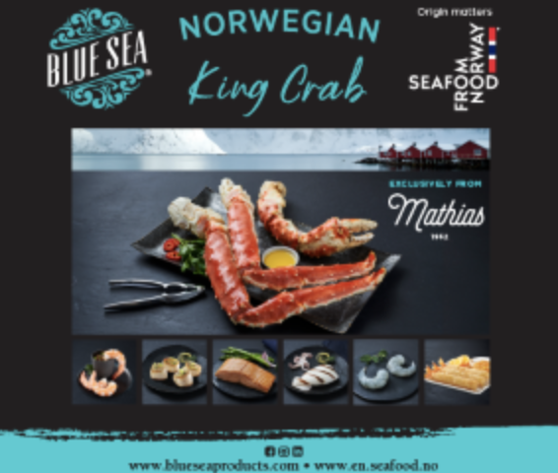
“Our company also utilizes the BAP standard management process, combined with the company’s digital traceability process, to guarantee the traceability of each fish from source to end,” Zhang said.
This year, Zhang is making a push to sell beyond China's borders, according to Zhang.
“We have very high expectations for the Southeast Asian market at this stage,” Zhang said. “Since the beginning of this year, when we first explored the international market, our product has been favored by customers from Southeast Asian countries and we hope to make more and better products for the southeast Asian market.”
Photo by Chris Chase/SeafoodSource

China's salmon consumption growth imperiled by higher import prices
June 22, 2022
Seafood Source
Mark Godfrey
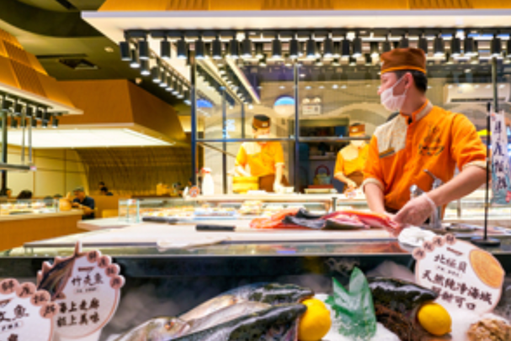
Chinese consumers are facing soaring prices for imported salmon, and that may not be good for long-term market growth, according to Fan Xubing, head of the Beijing-based seafood marketing consultancy Seabridge.
Exports of fresh Norwegian Atlantic salmon to China increased 67 percent in value year-on-year between January and May 2022, even while dropping 11 percent in volume. That jump is part of a global surge in salmon prices as many global markets bounce back following years of COVID-19-related dining and public gathering restrictions, according to Andreas Thorud, the Norwegian Seafood Council’s representative in China.
“In addition, global developments outside the seafood industry, such as increased inflation and the war in Ukraine, have also contributed to higher food prices,” Thorud told SeafoodSource.
But Chinese consumer demand for salmon is now weakening, as the higher prices are stamping out any growth in salmon consumption, Fan said.
“In China, fresh salmon is 80 percent or more consumed in Japanese restaurants and the very strict control of COVID-19 in [the] first half [of] 2022 in China – especially in Shanghai, Beijing, Guangzhou and Shenzhen – restrained the demand for fresh salmon from the HORECA [hotel, restaurants, catering] segment in China,” he said. “This means Chinese consumers are forced to accept much higher salmon prices. Of course, consumers of fresh salmon are normally higher-income people and they [can] probably afford the high price for a while.”
In the long run, however, higher salmon prices in China will “destroy” healthy market demand for salmon “and consumers might shift to other species,” he said.

Fan told SeafoodSource he sees Chinese consumers shifting more and more to domestic seafood and cheaper imported seafood in 2021 and 2022. He suggested the NSC should focus on consumer education and explaining “what's the value of such high-priced salmon for Chinese consumers.”
More-expensive imports may be providing a boost to China’s limited domestic supply. Chinese salmon producer Gansu Wenxiang Ecological Fishery Co. reported a major bounceback in revenue in 2021 thanks to a reopening of the catering sector, according to the company’s latest financial report. Based in China’s northwest, the firm lifted its revenues by 338 percent in 2021 compared to 2020, while booking an annual profit of CNY 15.4 million (USD 2.25 million, EUR 2.1 million). Established in 2011, the company has an annual production capacity of 3,000 metric tons (MT) and has benefitted from governmental funding for rural poverty alleviation.
Another firm, Xinjiang Tianyun Organic Agriculture Co., which produces rainbow trout, had a “much-improved” year in 2021, the company’s CEO, Zhang Yuru, told SeafoodSource. The company benefitted from higher prices, Zhang said.
Fan said higher prices for imported salmon have helped local finfish aquaculture firms post positive results.
“When imported salmon prices rise, local farmed trout will replace part of the imported salmon position,” he said. “Another reason is in 2021, our government set restrictions on imported seafood and that gave local trout farmers a good opportunity.”
Continued lockdowns in Chinese cities have resulted in a dour economic forecast for China’s economy this year. In May, the investment bank Goldman Sachs lowered its projection for China’s GDP growth in 2022 to 4 percent, from 4.5 percent previously, and cut its projection for growth in the second quarter to 1.5 percent year-on-year from an earlier prediction of 4 percent.
In 2021, overall seafood consumption in China reached 68.8 million MT, up 2.3 percent year-on-year, but of that figure, only 29.6 percent went toward human food consumption. China’s overall seafood output, at 66.9 million MT, was up 2.2 percent year-on-year, with aquaculture production up 3.1 percent to 53.8 million MT.
Photo courtesy of Sorbis/Shutterstock
China’s top fruit processor plans big push into RAS salmon, shrimp aquaculture
February 9, 2021
Seafood Source
Mark Godfrey
China’s leading vendor of fruit and vegetables is launching an ambitious foray into salmon and shrimp aquaculture.
The Haisheng Group, which is publicly listed on the Hong Kong Stock Exchange, is looking at investing CNY 5 billion to CNY 10 billion (USD 800 million to USD 1.6 billion, EUR 1.3 billion to EUR 650 million) in 15 to 20 aquafarming facilities across China by 2030, the company told SeafoodSource.
After detailed research into potential locations around the country, the firm has settled on the provinces of Gansu, Guangxi, Hubei, Ningxia, and its home base of Shaanxi. It’s also planning to build a salmon farm with a projected annual output of 5,000 to 10,000 metric tons in the Bole region of Xinjiang Province, a region in China’s far west, bordering central Asia. Additionally, the firm is looking at installing a CNY 360 million (USD 54 million, EUR 46.8 million) salmon project in Qinghai province at the foothills of the Himalayas with a projected annual output of 5,000 MT.
One of Haisheng’s shrimp projects will be located in the semi-tropical region of Guangxi, near the Vietnamese border, where the company will invest CNY 160 million (USD 25.6 million, EUR 20.8 million) in a project with an annual capacity of 2,000 MT.
Haisheng aims to use recirculating aquaculture systems (RAS) for its shrimp and salmon production “but in shrimp we consider the RAS and ponds mode, because [using] only RAS system will be very expensive and not profitable,” company spokesperson Simon Li told SeafoodSource.
Li said the firm has the resources and network to make a successful venture in aquaculture.
“Our company is a National Leading Enterprise for Agriculture Industrialization in China. Now we have 96 agricultural bases, with total areas of 15,000 hectares, so we will launch our projects all over the country,” he said.
Founded in 1996 in Shaanxi Province, the Haisheng Group is the world’s leading producer of juice concentrate in volume terms. The group’s publicly traded arm, China Haisheng Juice Holding Co., was listed on the Hong Kong main board in 2005, and since 2012, the firm has pursued a strategy of building a full value-chain in the growing, processing, and retailing of fruit and vegetables. The company has opened its own chain of stores, concentrating on growing urban demand for high-end fruit and vegetables. It also exports juices.

China’s domestic salmon sector facing pressure from bad economy, Norwegian imports
May 28, 2020
Seafood Source
Mark Godfrey
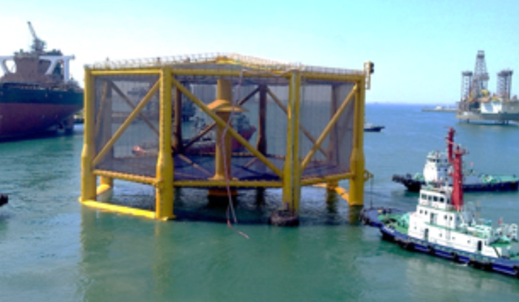
China’s economy is weakening, and that could spell the end of the country’s fledgling marine salmon sector.
In April, the CKGSB Business Conditions Index (BCI) registered a score of 42.2, up less than one percentage point from March (41.3), but well below the 50-point mark, which suggests a positive reading. The latest monthly reading of the index, compiled by the respected Beijing business school of the same name, comes with a warning for the future.
“From this, we can tell that the economy is still extremely weak,” the BCI report said. “Without strong government policy intervention, economic growth is unlikely to be very positive going forward. Indeed, if by the end of the year, GDP growth is above zero, this will be considered a decent result.”
China’s ability to stimulate its economy in the way it did during the global financial crisis is limited by the debt load at both the corporate and government levels, restricting the government’s use of the state-owned banking sector to funnel cash to corporations and real estate developers. Corporate debt stands at 122.9 percent of GDP.
The weak underlying economy in China, combined with a collapse in salmon consumption and prices triggered by the coronavirus outbreak lockdowns, has spelt real trouble for domestic salmon farming, according to Fan Xubing, who runs Beijing-based seafood marketing agency Seabridge.
“The advantages of domestic salmon farming are mainly the short distance to market and lower transportation cost and also [exemption from any] import duty. But domestic salmon farming cost is higher than Norway and Chile [and] many technical problems about marine farming of Atlantic salmon in China have not been solved and I don’t know if they [can] overcome these difficulties in near future or not,” Fan told SeafoodSource.
In recent years, there have been numerous high-profile launches of local salmon-farming start-ups. But thus far, China’s marine-water Atlantic salmon farming projects have struggled, according to Fan, pointing to Rizhao Wanzefeng, Tianjin Neptune Star (Weihai Blue Sea), and Dongying Agri-Marine.
“None of them has been successful so far,” he said.
One of the oldest and biggest players in the sector, Shandong, China-based Oriental Ocean, spent a decade building out its land-based salmon-farming operations, betting on the attraction of fresh salmon to Chinese consumers. But in February, the company made the decision to sell its land-based Atlantic salmon RAS farming business to Qingdao Guoxin Development (Group) Co., which burst onto the aquaculture scene last year when it contracted to build a 100,000-ton aquaculture platform to be docked in the Yellow Sea.
The sale represents a failure for the industry, according to Fan. He said if Oriental Ocean couldn’t get the business to work, it’s unlikely that Guoxin will, given its lack of experience in the global salmon market.
“I personally think this acquiring is not a good business for Guoxin,” he said.
A new start-up, Neptune Ranch is developing salmon production in the Yellow Sea. It completed a pilot cage operation last summer and moving to a commercial cage later this year with smolts supplied by Oriental Ocean. According to a veteran Western salmon expert who’s advised several Chinese firms, the success Weihai Blue Sea – and those of its peer in the sector – is dependent on leaning heavily on technology and processes that have been proven successful in more established salmon-farming countries.
China’s economy is weakening, and that could spell the end of the country’s fledgling marine salmon sector.
In April, the CKGSB Business Conditions Index (BCI) registered a score of 42.2, up less than one percentage point from March (41.3), but well below the 50-point mark, which suggests a positive reading. The latest monthly reading of the index, compiled by the respected Beijing business school of the same name, comes with a warning for the future.
“From this, we can tell that the economy is still extremely weak,” the BCI report said. “Without strong government policy intervention, economic growth is unlikely to be very positive going forward. Indeed, if by the end of the year, GDP growth is above zero, this will be considered a decent result.”
China’s ability to stimulate its economy in the way it did during the global financial crisis is limited by the debt load at both the corporate and government levels, restricting the government’s use of the state-owned banking sector to funnel cash to corporations and real estate developers. Corporate debt stands at 122.9 percent of GDP.
The weak underlying economy in China, combined with a collapse in salmon consumption and prices triggered by the coronavirus outbreak lockdowns, has spelt real trouble for domestic salmon farming, according to Fan Xubing, who runs Beijing-based seafood marketing agency Seabridge.
“The advantages of domestic salmon farming are mainly the short distance to market and lower transportation cost and also [exemption from any] import duty. But domestic salmon farming cost is higher than Norway and Chile [and] many technical problems about marine farming of Atlantic salmon in China have not been solved and I don’t know if they [can] overcome these difficulties in near future or not,” Fan told SeafoodSource.
In recent years, there have been numerous high-profile launches of local salmon-farming start-ups. But thus far, China’s marine-water Atlantic salmon farming projects have struggled, according to Fan, pointing to Rizhao Wanzefeng, Tianjin Neptune Star (Weihai Blue Sea), and Dongying Agri-Marine.
“None of them has been successful so far,” he said.
One of the oldest and biggest players in the sector, Shandong, China-based Oriental Ocean, spent a decade building out its land-based salmon-farming operations, betting on the attraction of fresh salmon to Chinese consumers. But in February, the company made the decision to sell its land-based Atlantic salmon RAS farming business to Qingdao Guoxin Development (Group) Co., which burst onto the aquaculture scene last year when it contracted to build a 100,000-ton aquaculture platform to be docked in the Yellow Sea.
The sale represents a failure for the industry, according to Fan. He said if Oriental Ocean couldn’t get the business to work, it’s unlikely that Guoxin will, given its lack of experience in the global salmon market.
“I personally think this acquiring is not a good business for Guoxin,” he said.
A new start-up, Neptune Ranch is developing salmon production in the Yellow Sea. It completed a pilot cage operation last summer and moving to a commercial cage later this year with smolts supplied by Oriental Ocean. According to a veteran Western salmon expert who’s advised several Chinese firms, the success Weihai Blue Sea – and those of its peer in the sector – is dependent on leaning heavily on technology and processes that have been proven successful in more established salmon-farming countries.
“From my experience, Chinese do not fully embrace advice from the established salmon aquaculture, and do not follow rigorous biosecurity,” the advisor said. “Also, in spite of top-notch technical advice and facility design, I often hear, ‘This is not the Chinese way,’” he explained to SeafoodSource. “Inevitably, Chinese companies will select the cheapest equipment that often fails from lower standards of construction.”
By contrast, “the industry in the West have invested large amounts of capital in R&D to make the industry successful,” the expert said. “There isn't the same level of expertise in China due to low-wage policies and outdated management practices.”
Even China’s faux-salmon – cold-water trout grown in China’s inland provinces and controversially marketed as “salmon” – has gone tough times recently, though it is touted as a bright spot in the domestic aquaculture scene. “China’s large-scale rainbow trout farming in Qinghai, Gansu, and Xinjiang has been shrinking since 2018 because of bad sales,” Fan said. “They have to reduce the price and sell trout with the ‘salmon’ name. But consumers don’t accept these trout as salmon.”
In the same way that oil-producing countries have looked to coronavirus-related price drops as a way to push upstart horizontal fracturing firms out of business, the recent drop in salmon prices could prove fatal for China’s salmon producers, which have long struggled with profitability.
Seen as the standard-bearer for successful salmon farming, Norway has significantly expanded its market presence in China since the world’s most-populous country ended its ban on Norwegian seafood imports in 2018. Norwegian exporters have begun delivering on Chinese consumers’ preference for fattier, large-size fish and are taking over market share from domestic firms, according to data from the Norwegian Seafood Council. Import figures for the first three months of the year show that Norway has a 36 percent market share of the Chinese fresh salmon market, while Chile holds 39 percent. Last year saw 168,500 tons of Norwegian seafood products imported to China, a 13 percent increase year-on-year, according to NSC statistics.
Norwegian salmon sales have boomed via astute marketing through China’s online sales channels. As an example, earlier this month, JD Fresh, JD.com’s fresh food unit, partnered with The NSC to launch an online seafood shopping festival involving names like Norway Seafoods. China’s leading microblog platform Weibo, meanwhile, has been jammed with paid video bloggers presenting videos on cooking and eating Norwegian salmon. The influencers are paid by salmon importers and distributors. Not surprisingly, sales of Norwegian seafood products via both online and offline channels of JD.com have increased more than 200 percent this year.
“Recent weeks, Norwegian salmon exports to China have seen a continued strong development,” Victoria Braathen, China director at the Norway Seafood Council, told SeafoodSource.
It helps that prices for imported salmon have been low due to drooping international demand for fresh Norwegian salmon as a result of the coronavirus crisis.
“Prices have fallen [but] are moving somewhat upward. Still, the current market is quite different from beginning of the year,” Braathen said. “The global situation is contributing to increasing availability of salmon that qualifies for and is meeting the China market preference.”
The easy availability of cheap Norwegian imports is bad – possibly even fatal – news for the domestic Chinese firms, Fan said.
“They still had some room to survive when global salmon price is high,” he said. “[But] when Norwegian fresh salmon price dropped 30 percent in the first quarter of 2020, [now] who will buy domestic salmon and trout?”
Braathen has suggested the NSC will be marketing Norwegian salmon more energetically than ever this year, implying Norwegian exporters feel confident they can continue to expand no matter what the Chinese economy does over the next year and beyond.
“We are very pleased to see that Norwegian salmon is increasing its presence in the China market as daily life and businesses are recovering [from the coronavirus crisis] … In the time to come, we look forward to further develop the market for Norwegian salmon,” she said. “We remain very confident about the market outlook and potential. We have seen over the course of this spring that a range of seafood products have got a momentum, and as the market is recovering, this represents new opportunities for both imported seafood such as Norwegian salmon [and] locally produced seafood.”
Photo courtesy of Wuchang Shipbuilding
MORE CONTEXT ON THAT FAKE SALMON CONTROVERSY IN CHINA

June 5, 2018

Qinghai "salmon" controversy is latest blow to consumer confidence in China

Mark Godfrey - seafood source
A mini-scandal was unintentionally sparked in China in late May by the national broadcaster CCTV, when it ran an upbeat report on its business channel on the success of “salmon” producers in the remote westerly province of Qinghai, at the foot of the Himalayas.
The region of Qinghai produces 30 percent of China’s overall salmon output, according to Wang Yu Hu, head of the Chinese Agricultural Ministry’s office in Qinghai, which has been keen to promote salmon raising as a revenue source for impoverished peasants.
However, soon after the report, rumors began on Chinese social media outlets that some opportunistic salmon trading firms may have been passing off locally raised Chinese rainbow trout as salmon. Soon, an online firestorm broke out among consumers worried they had been paying top-dollar for what they’d assumed was imported salmon but which was rather Qinghai trout.
The incident could potentially shatter confidence in salmon among Chinese consumers who have been the object of so much attention from Norwegian and Chilean salmon exporters. Salmon’s recent success in China has been driven by a massive marketing spend by the Norwegian Seafood Council and the adoption in China of Japanese dining trends. Sensing a lucrative opportunity, local governments across China have dived into salmon and trout farming in a bid to make money.
The Qinghai salmon controversy is yet one more wake-up call for a Chinese seafood industry that has become synonymous with fraudulent appellations and rip-offs. There are many traders on various Chinese online grocery stores selling “snow cod” and “black cod” that may in actuality be pollock. Priced at a premium, these “cod” filets are marketed as having health benefits for children and the elderly.
There are other dubious health claims made by seafood sellers in China. Sea cucumber and abalone smuggled from Mexico, South Africa, and Australia are promoted as a cure-all for men’s health. Various products are promoted and sold as “wild and undomesticated” from the “deep oceans” – with little factual evidence or details on product specifications or origins.
Another form of fraud, restaurant overcharging, has become commonplace in coastal cities. Eateries charge astronomical sums for species like lobster, shrimp, and salmon labeled as “wild,” “pure,” and “ecological” seafood, but offer little or no information as to the supplier, the source waters or other details that might substantiate the pricing.
Another ruse, frequently used on the holiday island of Hainan, sees diners charged per prawn, having ordered on the assumption that prices referred to a dish of shrimp. And in northern Chin, an unlucky diner faced a bill close to USD 1,000 (EUR 857) for a single sturgeonfish in the city of Harbin. The restaurant made all kinds of unverifiable claims as to the sturgeon’s origins and nutritional value.
Chinese restaurants use the offer of “rare” and “wild” seafood as a selling point in a dining culture where hosts seek to impress guests with rare, pricey dishes. For a nation with a reputation as a collection of thrifty savers who bargain hard, Chinese consumers have proved all too willing to unquestioningly accept the claims of food vendors.
It’s in this opaque environment that Qinghai trout becomes imported salmon. One-third of salmon sold in China is supplied from local sources, according to the China Fisheries Association, which doesn’t state how local and imported supply are differentiated. “Salmon” is a mere marketing term, according to the association, which argues that trout is part of the oncorhynchus species that also encompasses Atlantic salmon.
According to an alliance of salmon and trout producers in Qinghai, the species being produced translate from Mandarin as salmon (oncorhynchus) and trout (salmo playtcephalus). That alliance claims local sales and exports of 1,600 tons in 2017, with shipments going to Korea, Japan, Russia, and the European Union, marketing its fish under the “Long Yang Xia” – the name of a lake-strewn area popular with tourists in China.
With so much confusion in the marketplace, the recent furor over the Qinghai “salmon” will potentially trigger wider demands for traceability and transparency in labeling from China’s seafood consumers. The situation has been changing somewhat with the success of new retail entrants to the industry, such as the Hema Xian Sheng chain of supermarkets being opened up nationwide by Alibaba. Its customer-focused service and transparency, through better labeling of products, make it the antithesis of China’s traditional retail scene. The promise of traceability and food safety is one of Hema’s strongest hands in attracting customers in China’s seafood sales, a scene that has long been dominated by wet markets and large supermarkets not known for their commitment to traceability.
There’s a role here, too, for the various certification schemes like the Aquaculture Stewardship Council and the Marine Stewardship Council, which are trying hard to get a foothold in China. Numerous Chinese seafood firms have secured international certification to bolster their exports. But embracing and declaring full traceability will be a feat slowly achieved, and in the meantime, buyers of seafood in China are best served by remaining skeptical.

Dahu Aquaculture flags losses on bad investments, environmental crackdown
February 4, 2020
Seafood Source
Mark Godfrey

One of China’s leading aquaculture companies has reported a poor 2019 financial performance due to a troubled diversification strategy and a stricter enforcement of new environmental rules by the Chinese government.
Dahu Aquaculture Co., which produces crabs and freshwater fish largely for the domestic market, is flagging losses of CNY 120 million to CNY 140 million (USD 16.8 million to USD 19.6 million, EUR 15.5 million to EUR 18.1 million); Losses at one of the firms it’s invested in through two subsidiaries has forced Dahu to write down CNY 60 million (USD 8.4 million, EUR 7.8 million) in impairments. Zang Dahu Investment Management and Hunan Dahu Private Equity Investment Fund (both vehicles set up by Dahu to invest in other companies outside the seafood sector) put the money into the Ao Ji Te Biotechnology Co., but now Dahu blames “poor corporate governance” at Ao Ji Te for its losses.
Conflict with local government over enforcement of environmental regulations has also dented Dahu’s 2019 earnings. The company is claiming between CNY 12 million to CNY 15 million (USD 1.7 million to USD 2.1 million, EUR 1.6 million and EUR 1.9 million) of its loss was down to a dispute with local government over Dahu’s right to put aquaculture facilities into Shanpo Lake and adjacent mudflat areas in the company’s home province of Hunan.
The company is in a legal fight over the withdrawal of a license it claims was secured in 2009 after government in 2019 sought to enforce national rules on mudflat protection. Likewise, the company claims government actions are counter-productive because its fish farm in the lake was contributing to drinking water quality due to “parasite-eating, purification fish.”
A similar dispute with local government in far westerly Xinjiang Province has cost Dahu CNY 36 million (USD 5 million, EUR 4.7 million) in losses in 2019, according to the company’s estimates, which it shared with investors. The company has been farming fish and crabs in Ulungur Lake, near the border with Kazakhstan, but is now fighting with the provincial government over whether its operations there can continue.
Dahu’s case is indicative of much tension between local government, national enforcement teams, and seafood firms over whether or not environmental regulations should be tailored and implemented by local officials, who have long been accused of ignoring policy from Beijing that hurts economic growth.
On the financial side, diversification is proving difficult for seafood firms. Tilapia exporter Baiyang has reported major losses for 2019 from its investments in media firms. Chinese companies and funds compete ferociously for investment opportunities in promising start-ups and small- and medium-sized enterprises – a competition which has become more urgent due to the slowing economy and mounting overcapacity in many traditional industries.
However, lack of due diligence and a comparative lack of transparency often means investments are poorly thought-out, a China-based compliance professional at a risk management company told Seafoodsource.
“There’s lots of me-too investments and bad bets because there’s relatively limited places for the cash to go, especially since there’s limits on currency exiting China, and there’s lots of cash in Chinese private equity firms,” he explained.

Shrimp farm to open in remote, restive Xinjiang area of China
January 21, 2020
Seafood Source
Mark Godfrey

The Xinjiang Benteng Biotechnology Co. aquaculture firm, in the far-westerly and politically troubled Xinjiang region, will see cultivation of shrimp (P. monodon) in the lower reaches of the Pamir Mountains near the Silk Road city of Kashgar.
The company has teamed with researchers from Shanghai Ocean University – an increasingly important source of China’s aquaculture and marine research – to cultivate the shrimp in the Tarim basin in an area known as Maralbexi (Ba chun in Mandarin) county. The location is near Kashgar, which is in the southerly capital of the region and closer to Pakistan and the Kyrgyz town of Osh than to most major Chinese cities.
The shrimp-farming pilot is being supported by local government as a poverty-alleviation program. Due to the area’s remote location – bordered to the north by the Tian Shan mountain range and to the south by the Kunlun Mountains on the edge of the Tibetan Plateau – the area has had less exposure to the economic gains realized by much of the rest of the country in recent years.
Starting up an aquaculture operation in the area could prove a challenge. The Taklamakan Desert dominates much of the vast space, which is renowned for the alkaline nature of the earth and for the existence of underground saline water bodies.
“If this works, it will prove that we can cultivate [shrimp] in even the deepest interior [of China],” Xinjiang Benteng Biotechnology Co. Chairman Chan Ya Yun said a statement to local media. Chan predicted the farm could be producing commercial quantities of shrimp by the end of the year.
Xinjiang has recently become a hotspot aquaculture developments in recent years, with an emphasis on crab breeding. Further north in the more verdant steppes on the Kazakh border, the Yili Crab Seeds Breeding Centre is producing seedlings for a burgeoning freshwater crab sector that previously relied on seedlings imported from far-away Jiangsu Province on the east coast.
“There was a big problem getting seedlings to acclimatize, so now we produce them locally,” a sales executive who answered the phone at the company told SeafoodSource. The salesperson said the company is now selling in both the provincial capital Urumqi as well as in inland Chinese city of Xi’an.
Xinjiang’s regional capital, Urumqi, is marketed as a trading hub for Central Asia in China’s Belt and Road Initiative (BRI) blueprint for global trade and the Xinjiang region will be linked to the Arabian Sea via the China Pakistan Economic Corridor, one of the BRI’s constituent parts.
The area has also been the center of ethnic unrest and a Chinese government campaign to stamp out what they’ve termed Islamic-inspired separatism amongst the native Uyghur ethinc group using mass internment camps.
Photo courtesy of Hrui/Shutterstock

